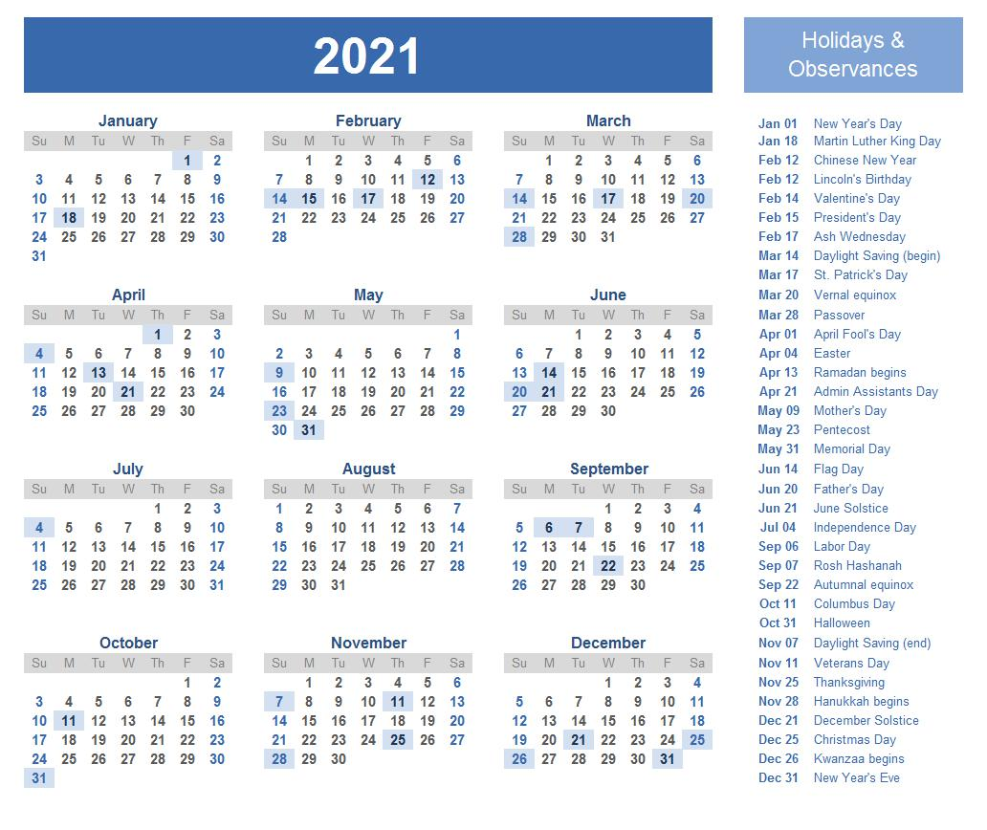

Copyrights Bestlettertemplate.com

