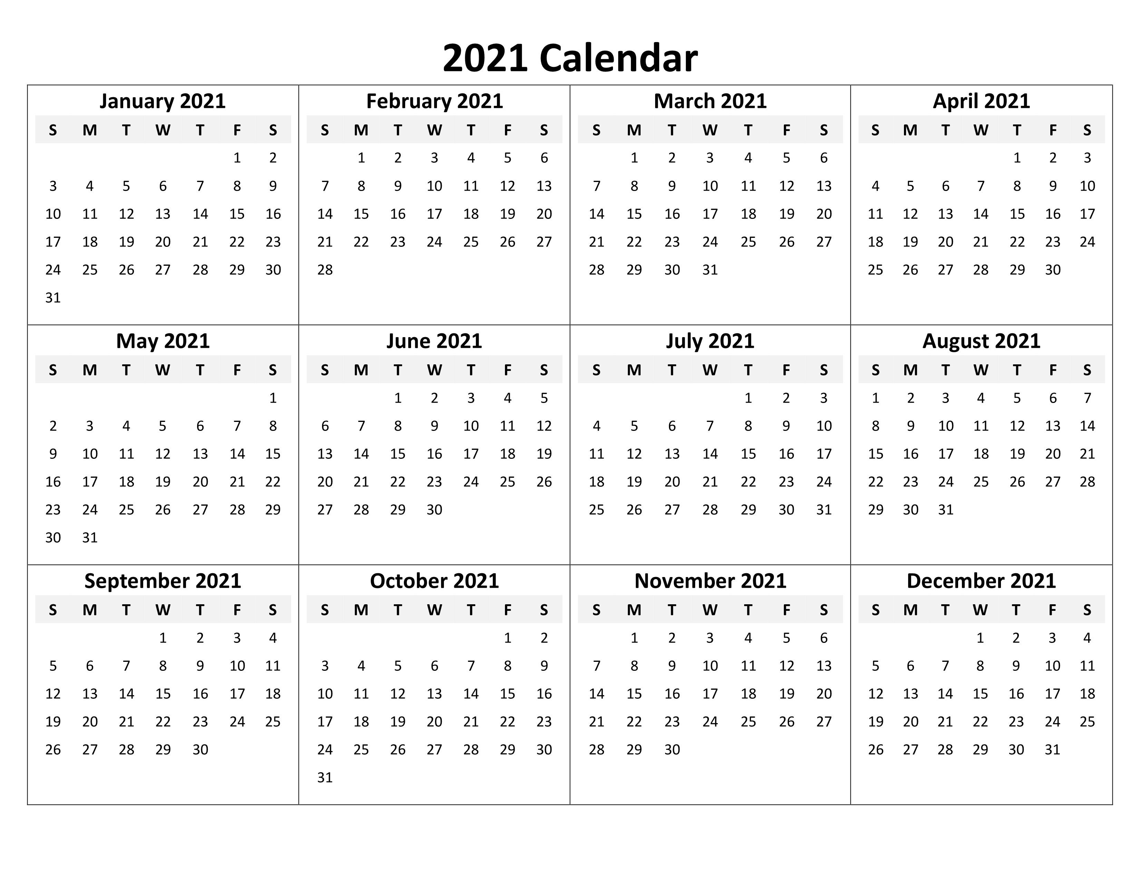

Copyrights BestLetterTemplate.com

