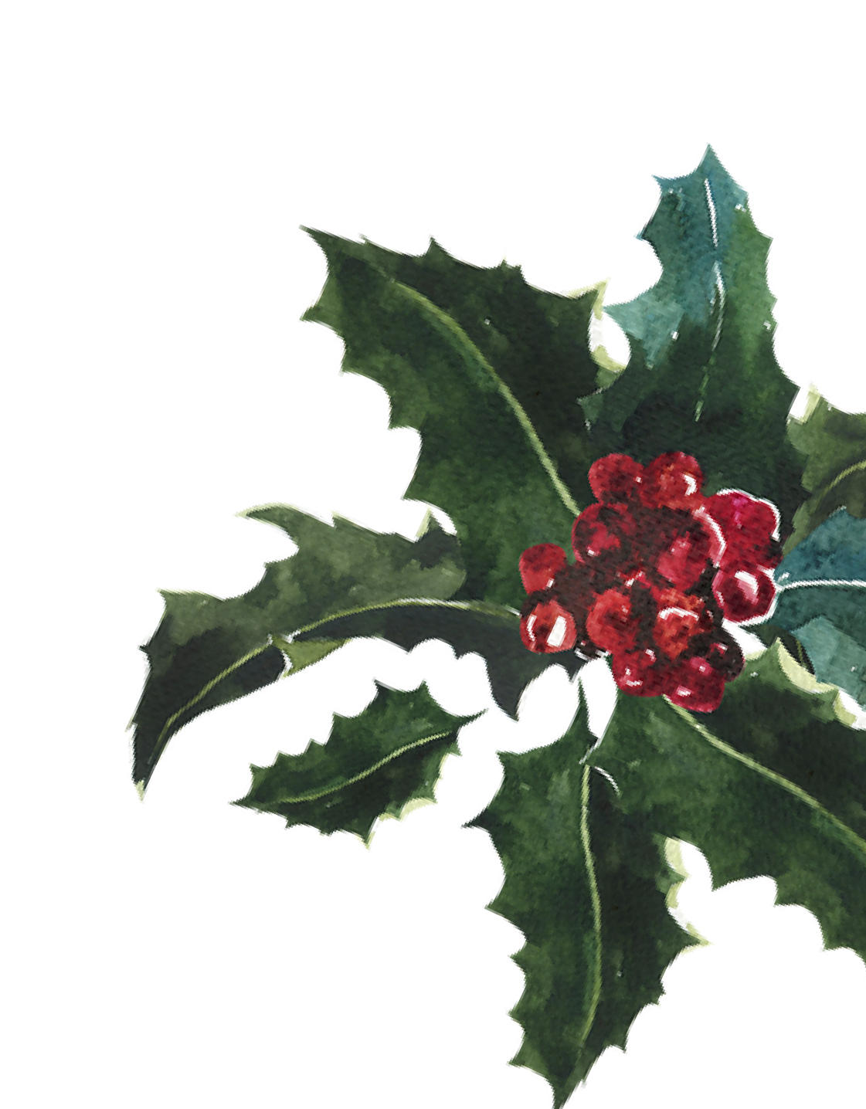Funny Christmas Letter

From,

To,

Subject:---------------------(Mention the purpose) Dear Santa,
I am writing this letter to you to wish you a Merry Christmas in advance. This year, I wish to meet you and also give you, my wishes. I like the gifts that you give. We all wish to give you wishes in person, and hence, we request you to come a bit early on the day of Christmas.

We will wait for you and will not go to sleep and remain awake only for you. I am writing this letter so that if we do not get a chance to meet, you accept my wishes in the form of this letter. May God Bless you and may God give you all the strength. Let this year be cheerful and prosperous for you. Merry Christmas in advance and have a prosperous New Year.

With Love,

Name Signature

