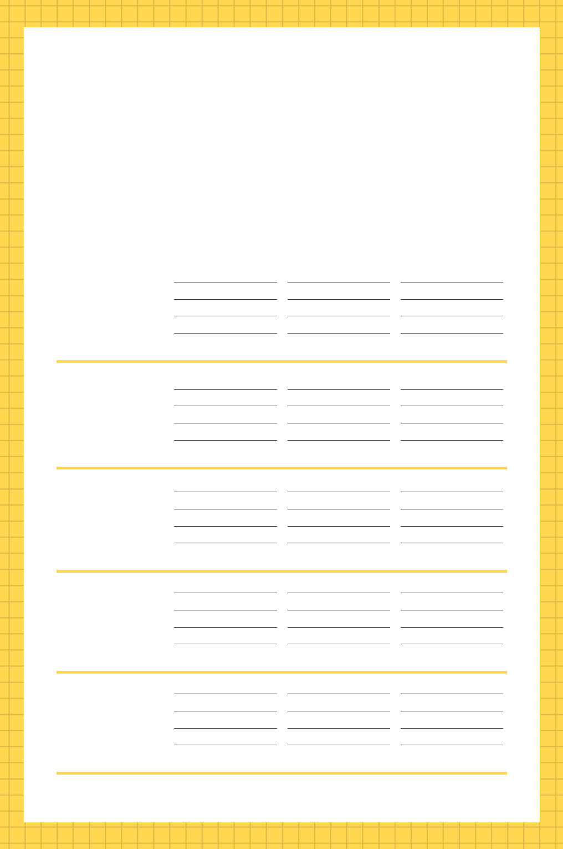

- EEKLY PLANNER

PHASE I PHASE II PHASE III

MONDAY

TUESDAY

WEDNESDAY

THURSDAY

FRIDAY

