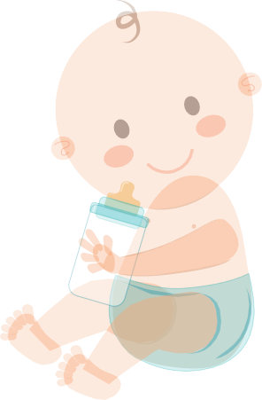

Baby sitting Gift Voucher

For: From:
Amount:
Signature:

